BFS DCG - WHITE PAPER CONTEST

ACHIEVING

STRAIGHT THROUGH PROCESSING (STP)

IN

CREDIT DERIVATIVES PROCESSING

AUTHORS:

Harish Kumar M S – 140636
Gokul Raman – 136502

Table of Contents

Abstract 3
Introduction to Credit Derivatives 4
Historical Growth of Credit Derivative 6
Concerns That Came Along With The Growth 7
Outstanding Confirmations: 7
Reason for Backlogs of outstanding confirmations 8
Risks associated with outstanding confirmation: 10
Immediate Market Reaction: 11
Technological solution 12
Way Forward - Achieving STP in Credit Derivatives Processing 13
STP Defined 13
Need or drivers of STP 13
Steps to Achieve STP through DTCC 14
Conclusion 15
Appendix 1 16
Appendix 2 17
References 18

Abstract

Securities and derivatives form the core financial investment structure of any economy. Credit derivatives evolved as an extension of these two pillars. The word derivative is called so because it is a contract that itself derives its value from an underlying contract. Credit derivatives were primarily invented to ensure “return of one’s capital than return on one’s capital”. In other words, its primary objective is to hedges oneself against the risk of loss of principal.

With Credit Derivatives playing a critical role in the risk management and growth of the financial market, there were a few factors that were threatening the growth of this market. There were operational inefficiencies that were becoming a bottleneck for the growth of credit derivatives.

In this white paper we have attempted to present the kind of growth that credit derivatives market has seen, bottlenecks threatening the growth, how the industry is currently overcoming these bottlenecks with the help of technology.

Introduction to Credit Derivatives

Credit derivatives are Over the Counter financial contracts designed to reduce credit risk. A credit default swap (CDS) is the most common type of credit derivative in terms of its utility. A credit default swap is similar to an insurance contract, providing the buyer with protection against specific risks. Most often, corporate bond investors buy credit default swaps for protection against a default by the issuer of the corporate bond.

One party to a CDS contract "sells" risk and the counterparty "buys" that risk. The "seller" of credit risk who also tends to own the underlying credit asset pays a periodic fee to the risk "buyer." In return, the risk "buyer" agrees to pay the "seller" a set amount if there is a default called as credit event. Commonly established credit events are bankruptcy, failure to pay, debt restructuring.

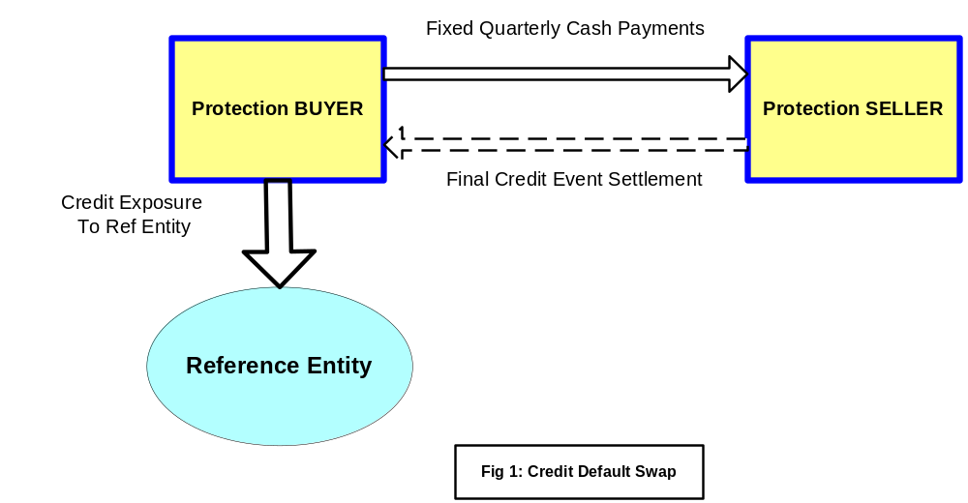
The fixed quarterly cash payments in the diagram referred to as premium prices also known as default swap spreads or “fixed rate amount” are quoted in basis points per annum of the contract’s notional value. Usually, predetermined premiums are paid by the buyer of protection to the seller on a quarterly basis, with the contract terminating either at maturity or at the time of a credit event occurring. The protection seller compensates the buyer for the loss if a credit event occurs by means of making the final credit event settlement referred to as the “float rate amount”.

Credit Derivatives – Tool for Managing Risks

Financial institutions are using credit derivatives to mitigate credit risk as an early protection against a credit event and to accept risk at prices that are favorable to them. Credit risk is defined as the risk due to uncertainty in the ability of a counterparty to meet its obligations. Because there are many types of counterparties from individuals to sovereign governments and many different types of obligations from say auto loans to derivatives transactions credit risk takes many forms. Firms have been investing time and effort to manage and mitigate this risk. Of the mechanisms available to market participants to protect themselves more comprehensively from these risks, the credit derivatives market especially the market for credit default swaps have emerged as a preferred option, and bankers have seen the acceptance of these hedging tools increasingly becoming visible across the entire financial services industry.
The compelling factor for the fundamental acceptance and growth of credit derivatives is the transfer of risk away from the balance sheets of banks and towards the much broader capital market, which is generally recognized as being more skilled and disciplined in terms of assessing and pricing credit risk. In this structure of synthetic securitization, the assets remain in the issuer’s balance sheet, while credit risk is transferred to third parties. This is a helpful way for banks without an urgent funding requirement to use the securitization market in order to achieve regulatory capital relief. In other words credit derivatives allow banks to manage their credit risk without funding.

Historical Growth of Credit Derivative
British Bankers Association expects the Credit Derivatives market to rise to $33 trillion by the end of 2008.
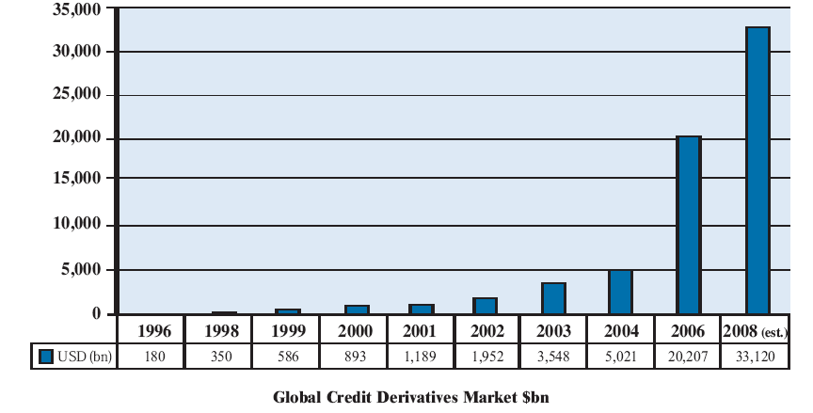
It is not just the size of the market that has been growing but also the diversity of products. Single name credit default swaps represent a substantial portion of the market with the index products taking the second place in the category.
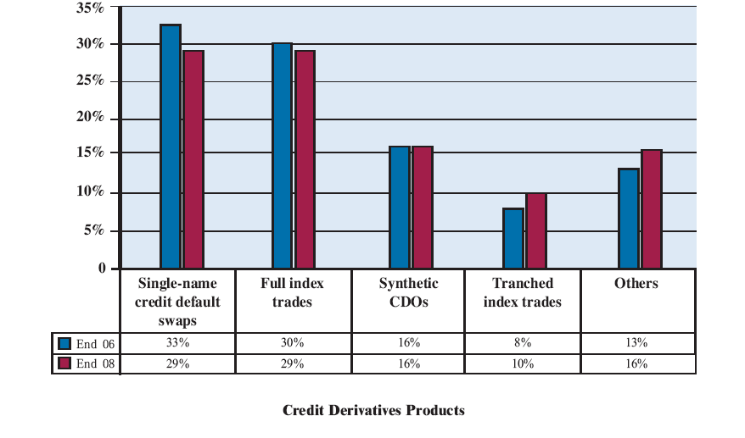

Concerns That Came Along With The Growth

The market’s dramatic expansion presented many operational challenges in front of the market participants. The back office was clearly unable to coup with the pace at which trades were booked by the Front office.

Outstanding Confirmations:

Confirmation Process:

A credit derivative contract or a trade is generally struck by both the counter parties over phone or through a Bloomberg Message, as it is OTC. The operations accompanying credit derivative trading occur in four distinct streams: trade capture, verification, confirmation and legal execution.

Once the deal is struck, the parties enter the trade details into their respective Trade Order Management System (OMS).

After the verification of trade details, a confirmation document containing both economic details such as fixed rate, float rate, payment frequency, trade date, effective date, scheduled termination date and legal terms and conditions as applicable for that trade (Non-Economic) is drafted by a drafting team. This document is sent to the legal team for approval.

Once the details are verified, the same is sent to the counter party for confirmation. After receiving the confirmation document from the other counterparty the verification team needs to verify these details with the document prepared by them and confirm if both of confirmation document agree on all the terms and conditions. This trade confirmation process acts as a proof that a trade has been completed.

Reason for Backlogs of outstanding confirmations

At any point in the whole process there could be some mistakes or errors that would be identified by either party to the trade before agreeing to the contract. Since these confirmations are legal documents, they need to be redrafted and verified again. This often causes the processing delays.

The Operations Benchmarking Survey conducted in 2006 by the ISDA revealed the following facts about delay that is seen in sending confirmations to the counter parties:

Delay in sending confirmations to Counter parties
- The cumulative confirmations dispatched to the counterparties on credit default swaps were only 93% even by Trade date + 5
- This is just a marginal increase over the 2005 figures
- As expected the survey pointed out that, vanilla products such as Forward Rate Agreements (FRA), vanilla interest rate swaps, and currency options take the least time to be dispatched. Relatively new or more complex products, such as credit derivatives and non-vanilla interest rate and equity derivatives, have the slowest dispatch times

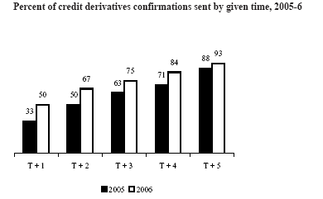
Out of the common reasons that could result in delays, the respondents were asked to rank the factors to understand their significance. For non-vanilla products like Credit derivatives the following factors were quoted to be making a significant impact in creating delays:

- New product
- Non-standard language
- Awaiting data or approval from legal or compliance

Delay in confirmation of the trades:

In 2004 the average outstanding confirmation for large firms stood at 25 days worth of new issuance. But the industry has seen some improvement on this aspect over the past two years. Respondents of the ISDA survey reported outstanding confirmations expressed as days worth of business, which is measured by dividing number of outstanding confirmations by daily volume of new trades. For example, if a firm has 100 unsigned confirmations and 10 new trades per day, the firm’s response is 10 days
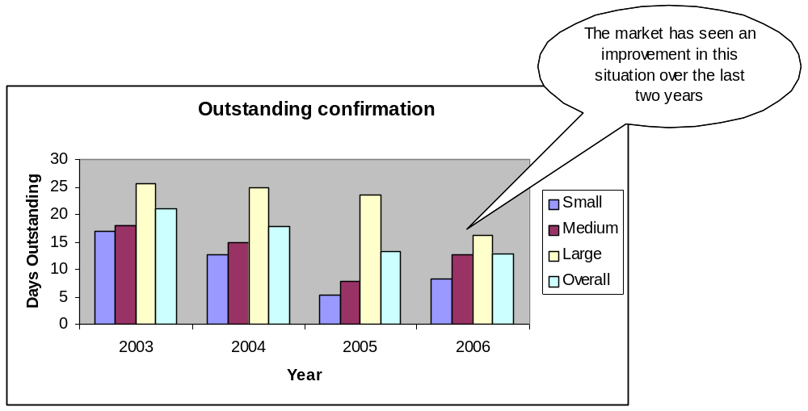
While there were many reasons that could be attributed to the backlogs in outstanding confirmation, the respondents of the survey sighted non-responsiveness from the counterparty and legal and compliance advice as significant factors causing the delay** (Refer to Appendix 1 for the manual confirmation process for a Credit derivative Trade)

Risks associated with outstanding confirmation:

- Without confirmation that a trade has taken place, parties to the transaction are exposed to legal and financial uncertainty
- If a credit event occurs while a credit-derivative transaction remains unconfirmed, doubt as to its legal validity and contractual responsibilities could prevent the transaction from being executed.
- This uncertainty could create liquidity problems and act as an accelerant in a financial crisis
This worrying situation drew the attention of the regulators/guiding bodies – ISDA (International Swaps Derivatives Association) and FSA (Financial Services Authority). The regulators directed the market participants to take immediate steps to clear the backlogs.

Immediate Market Reaction:
As a result of the regulator’s interference and the excessive risk that each of the participants were exposed to, the major participants in the market came together and promised to bring down the backlogs of outstanding confirmation under control.
As a quick measure, the participants had to sort to the manual process of clearing the backlog which increased back office (trade processing) the staffing ratio significantly.

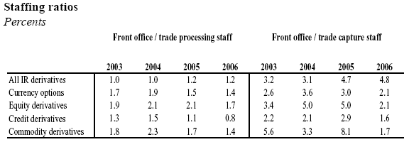
There was need to increase the manual processing because the level of automation in the confirmation process was significantly low. The survey by ISDA attempted to understand the level of automation in the processing of credit derivatives.
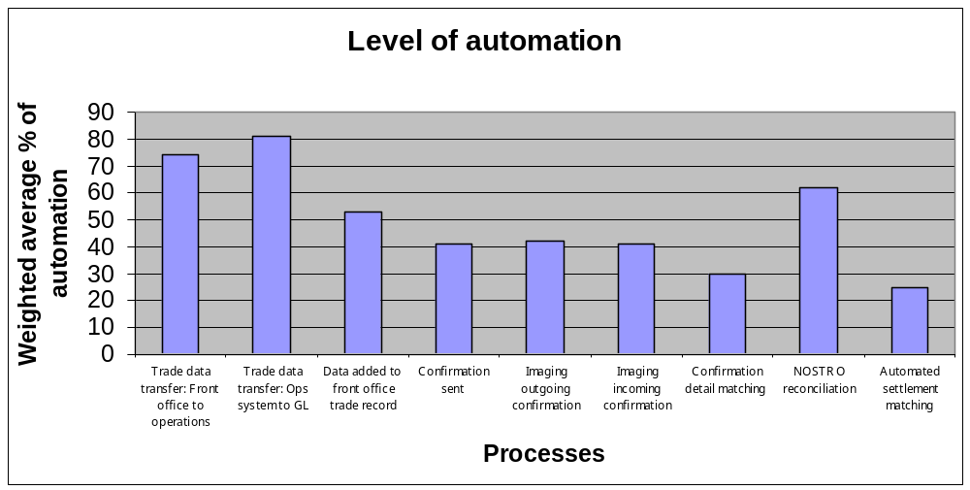The results were as under:
Percentage of automation is as low as 30% for confirmation matching

This highlights the inherent need for investment in technology and achieve Straight Through Processing (STP) in processing credit derivatives

Technological solution

Initiatives such as DTCC Deriv/SERV have its online trade matching and confirmation system that facilitates reduction of operational & credit risk for the market participants.

Automating the confirmation management
- Reduces the operational risk of manual errors
- Brings down the backlogs of outstanding confirmation which would intern reduce the credit risk that the participants face against a particular counterparty

Owing to the above benefits of automating the trade affirmation and confirmation management, the market participants are increasingly recognizing the benefits of the technology solutions provided by DTCC (Refer to Appendix 2)

DTCC has two products namely AffirmXpress and Deriv/SERV (Refer to Appendix 2) to cater to the automation of trade affirmation and trade confirmation respectively.

Way Forward - Achieving STP in Credit Derivatives Processing

STP Defined

STP enables the entire trade process for capital markets and payments transactions to be done electronically without the need for any manual intervention or trade enrichment. There are a number of stages in the life cycle of a trade. Historically, each stage or process had its own database and they did not talk to each other and each required repeated manual intervention.

Need or drivers of STP
The ISDA operations benchmarking survey for 2006 states
- Trade data capture, measured as front office error rate and percent of trades rebooked, showed mixed results. Credit derivatives error rates increased at large firms, but appear to be following a downward trend since 2003. Rebooking increased significantly, which might be the result of intensified efforts to reduce confirmation backlogs.
- Looking to future automation efforts, respondents expect to focus automation efforts more on credit derivatives than on other products. Among functions, respondents expect to focus on confirmation dispatch and on confirmation detail matching.
The Basel II norms are clearly drivers for straight through processing in credit derivative market since both credit and operational risk are two key elements of the proposed regulation.

Steps to Achieve STP through DTCC

Step 1

First step in achieving STP for credit derivatives processing would be to integrate the trade capture or affirmation systems with DTCC’s trade information warehouse; this could be achieved in three ways;
- Parties who do not possess an Order Management System (OMS) could use DTCC’s AffirmXpress as the OMS for the trade affirmation which would eventually flow into the DTCC’s matching/confirmation system for matching
- Parties who have their own OMS but do not have the deep pockets to invest in a Mainframe to mainframe FpML (Financial Products MarkUp Language) interface could route their trade details to DTCC through CSV (Comma Separated Values) interface mechanism
- Parties who have their own OMS and also the infrastructure to support FpML could route their trade details to DTCC through FpML messaging

Step2

Once the trade information is captured into the Deriv/SERV platform by one of the above three means, Deriv/SERV does the matching of the trade details and sends confirmation messages to both the counter parties in the event of a complete match. If the trade information does not match, the online platform provides the facility to the participants for resolving the mismatches

Step 3

For the confirmed trades, DTCC’s trade information warehouse would perform the role of a clearing house in calculating the coupon payment obligations that needs to be paid by the protection buyer to the protection seller and intimating the participants about the same

When a Credit Event occurs, the trade information warehouse would perform the credit event processing in arriving at the net settlement amount to be paid by the protection seller to the protection buyer.

Step 4

The final step of DTCC would be to arrive at the net payment obligations between the participants and send settlement instructions to a central settlement bank through which the actual settlement could be done.

Conclusion

Owing to the credit and operational risk being involved in the manual processing of credit derivatives, there has been increasing pressure for the market participants to comply with Basel II norms to keep these risks under control. Hence the market participants are forced to invest considerable resources in managing these risks which is not a value added activity.

Achieving STP eliminates the manual intervention in the processing credit derivatives trades which reduces the operational risk and also prevents the creation of backlog which reduces the credit risk in the market. Eventually this would result in considerable cost savings and serve as a launch pad for the exponential growth of this market.

Appendix 1

Manual Confirmation Management Process Flow

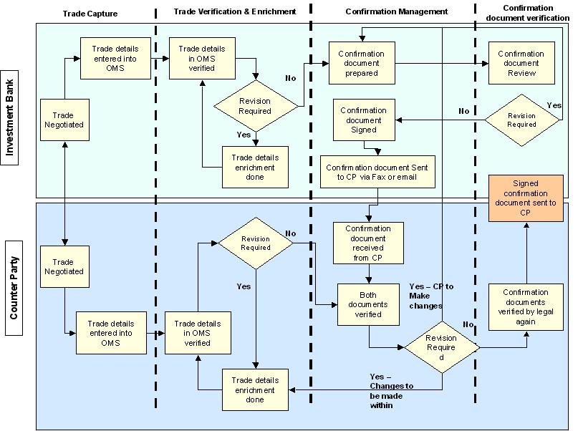

Appendix 2

DTCC
The Depository Trust & Clearing Corporation (DTCC) through its subsidiaries provides clearance, settlement and information services for equities, corporate and municipal bonds, government and mortgage-backed securities and over-the-counter credit derivatives.

DTCC's depository also provides custody and asset servicing for more than two million securities issues from the United States and 100 other countries and territories. In addition, DTCC is a leading processor of mutual funds and insurance transactions, linking funds and carriers with their distribution networks.

DTCC Deriv/SERV
It’s a new matching service for over-the-counter derivatives that is rapidly gaining industry acceptance as the preferred solution in derivatives post-trade processing, brings automation, standardization and greater certainty to this market for the first time. Using existing mainframe-to-mainframe connections The Depository Trust & Clearing Corporation has with firms, DTCC Deriv/SERV's process is conducted in real-time, highly automated, and identifies errors for correction immediately. A front-end Web interface rounds out the offering, whether for trade comparison input, on-line research, or management reporting.

DTCC AffirmXpress
Its a single-screen affirmation platform that allows traders and front-office staff to affirm credit derivative trades from multiple inter-dealer brokers (IDBs) at the point of trade

References

- ISDA 2006 & 2005 Operations Benchmarking Survey
- Market Participant’s letter to the Federal Reserve Bank of New York – Dated 4th Oct’05
- Report by Lauren Teigland-Hunt And Ryan Patino, Teigland-Hunt & Associates LLP - Taming Credit Derivatives: Assessing the Private Sector Response to Regulatory Concerns
- http://www.dtcc.com/ProductsAndServices/derivserv/index.htm
- http://www.isda.org

